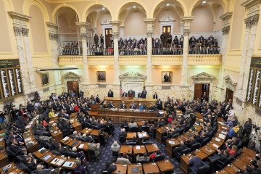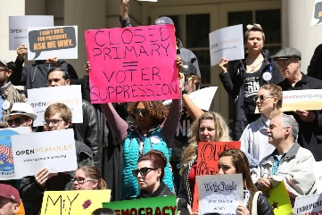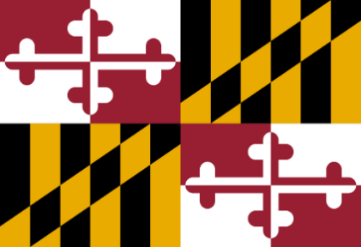

- **For Maryland’s state legislators to enact laws that implement Open Primaries in Maryland.**

**What do we advocate?**

* **The Independent Voters of Maryland is a group of independent-minded voters.**
* **We believe primaries are more important than the general election in deciding who represents us.**
* **We share a goal of allowing over 800,000 unaffiliated Maryland citizens to vote in primaries.**

**For more information  
 and contact info, visit our website & our national affiliate’s website:**

**It is essential that all voters, including unaffiliated voters, participate in the primary elections to ensure a strong democracy. Being denied the power to select candidates that would best serve our communities leaves many voices unheard on the issues that concern them. Overall, primary elections are one of the most crucial elections in our democracy. Regardless of political affiliation, we all deserve a chance to vote in the primaries.**

**A Message to   
Maryland Voters**

**Who Are We?**

**Open Primaries   
in Maryland  
*- from the   
Independent Voters of Maryland***

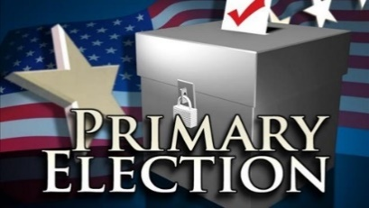

**Independent Voters of MD website:**   
https://www.independentvotersmd.org/

**Independent Voting website:**   
https://independentvoting.org/

**For a better democracy, primaries should be open to all voters!**

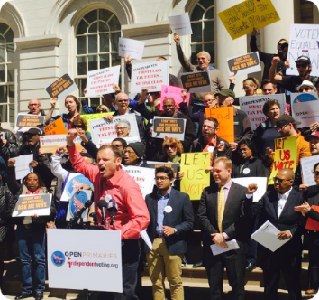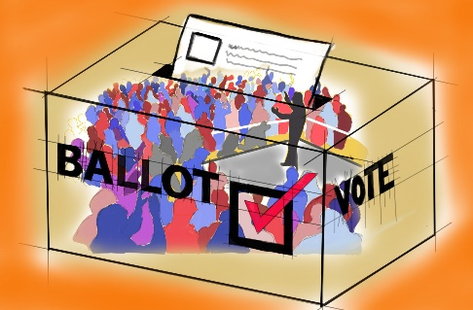

* **The 831,000 unaffiliated voters in Maryland have already grown to 20% of all voters. By 2035, unaffiliated voters will be the second**- **largest group of voters in Maryland.**
* **Across our Nation, 42% of Americans consider themselves independent,   
  even though they may be registered as Democrats or Republicans. Among millennials, 50% consider themselves independent.**
* **Voters are tired of the partisanship within the main political parties which results in too little progress on many important problems.**

**Ways to advocate for   
Open Primaries?**

* **Have conversations with friends, colleagues, and neighbors.**
* **Send local newspapers and websites op-ed articles and letters to the editor.**
* **Write, email, and talk   
  with your state representatives.**
* **Attend public meetings and political events.**
* **Vote for candidates who support Open Primaries.**
* **Join us at Independent Voters of Maryland.**
* **Open Primaries result in a stronger, less partisan, more inclusive, and more effective democracy.**
* **Open Primaries expand voting rights and voting freedom.**
* **Open primaries will allow voters to relate more with the individual candidate rather than with political parties.**
* **Open Primaries upgrade   
  and modernize Maryland’s election system to one already used in most of our Nation.**
* **Primary elections are funded by all Maryland Taxpayers!**

**Who are unaffiliated & independent voters?**

**Why have Open Primaries in Maryland?**